**ADVANCED DATABASE PROJECT**

**Vinyl Record Collection Manager**

**Work package 2**

**“User guide”**

GROUP C

Muhammad Ahsan (EPUN)

Pham Hoai Vu (EPUN)

Rosa Tsegaye (ULY2)

Farhad Nooralahzadeh (ULY2)

Punyavee Napalai (ULY2)

*February 12, 2012*

**Document Change History**

|  |  |  |  |
| --- | --- | --- | --- |
| Version | Date | Responsible | Reason for Change |
| 0.1 | 10/02/2012 | LYON team | Initial version |

**Table of content**

Getting started

Registering new account

Logging In

Editing your profile

Searching music

Navigating around the site

Finding more about us

**Getting started**

Joining the music community has never been easier, VinylMaster provides everything you need for creating your account, building up music database and searching music information.

**Registering new account**

*Click “Register” tab*

You need to input certain information for registering your new account. After you submit the information to the website, you will receive a confirmation email to validate your account. Click on the link and your account will be active to log in.

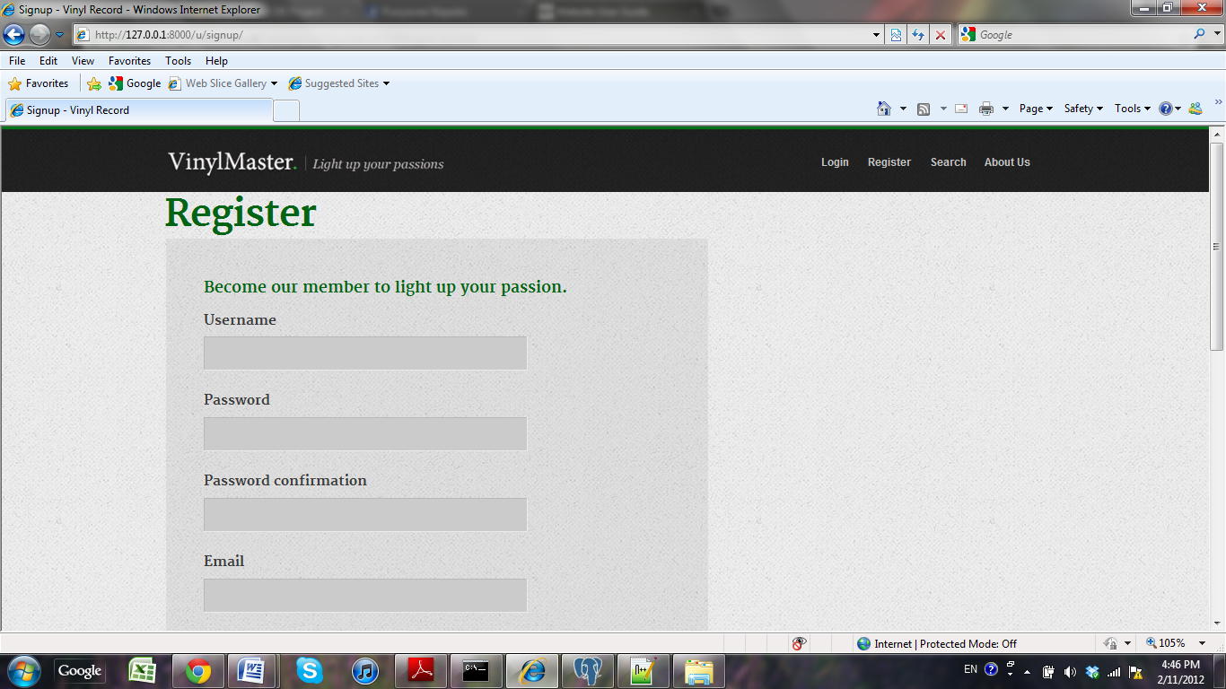

**Logging in**

*Click “Login” tab*

After you have registered your account with us, you can log in to your own account. Just type in your username and password to log in.

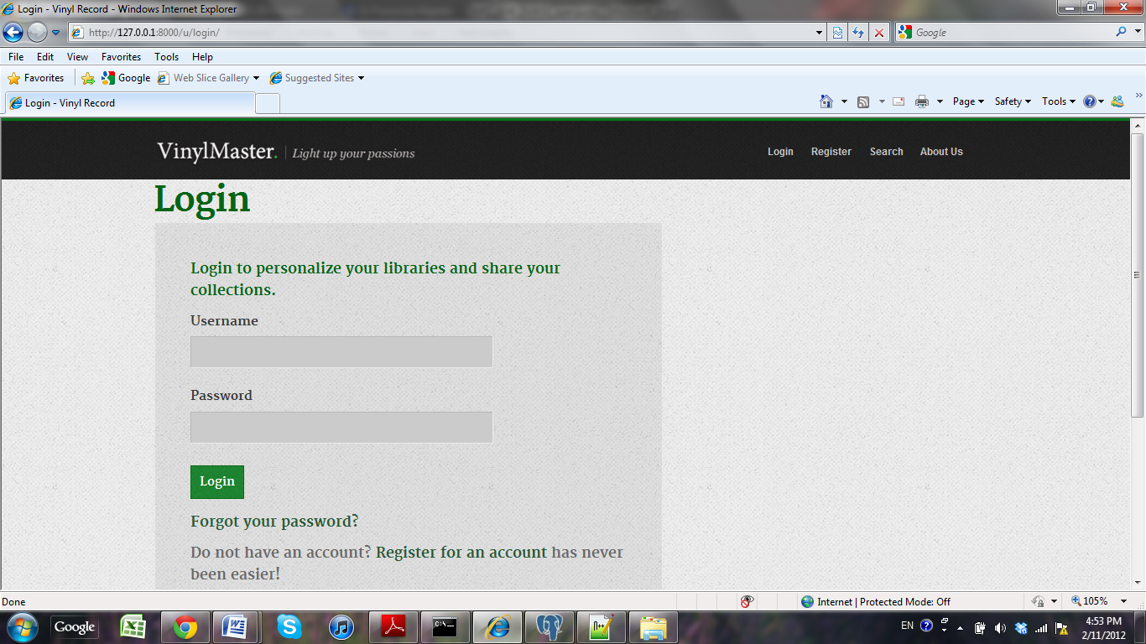

If you forget your password, you can click “Forgot your password?” to get your password by supplying your email address.

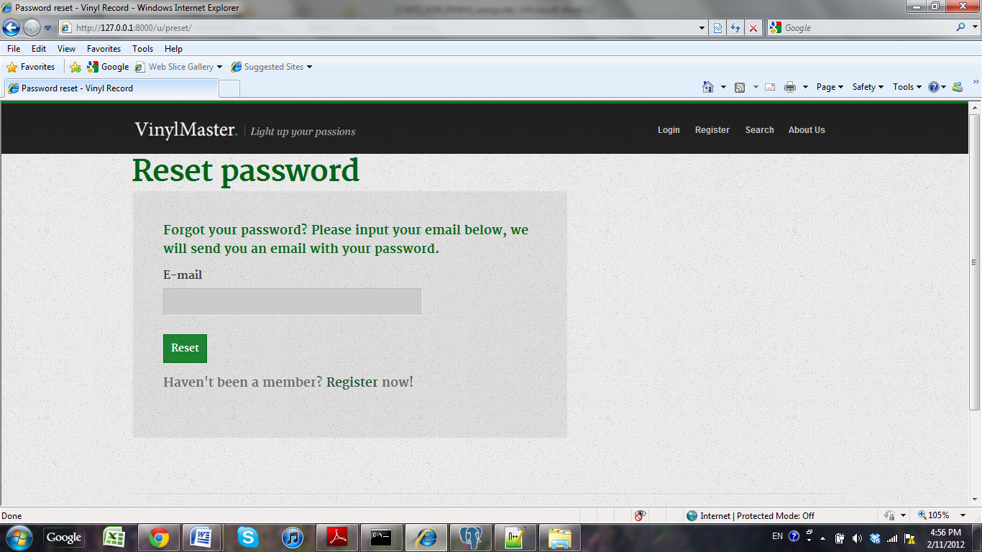

When you successfully log in your account, you will be leaded to your profile.

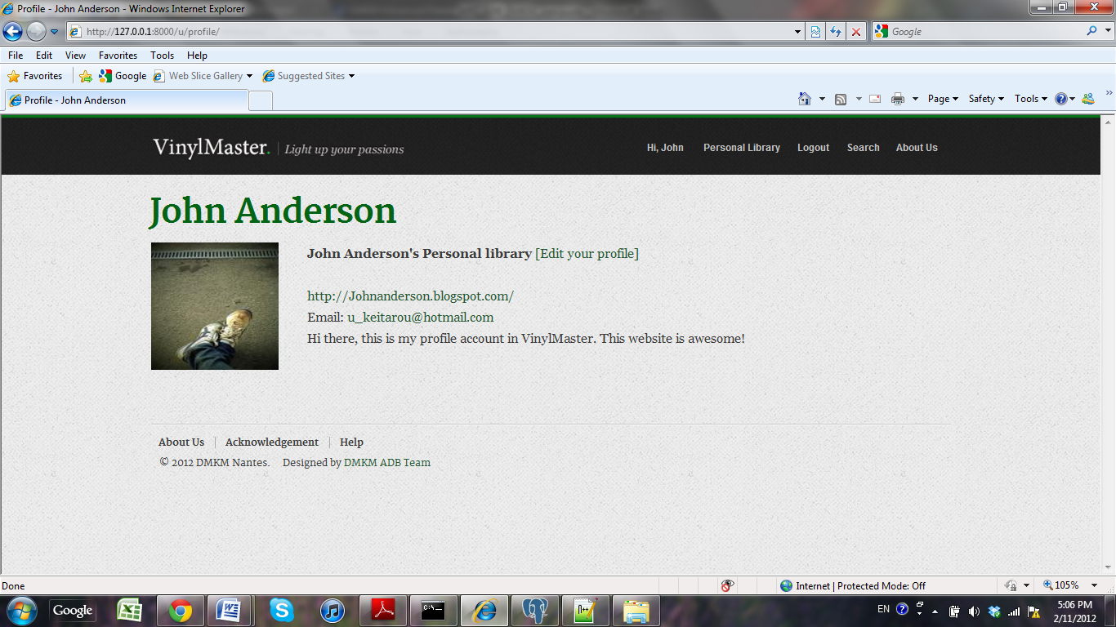

**Editing your profile**

*Click “Edit your profile” tab*

You can customize your account by clicking on “Edit your profile” in your Profile page.

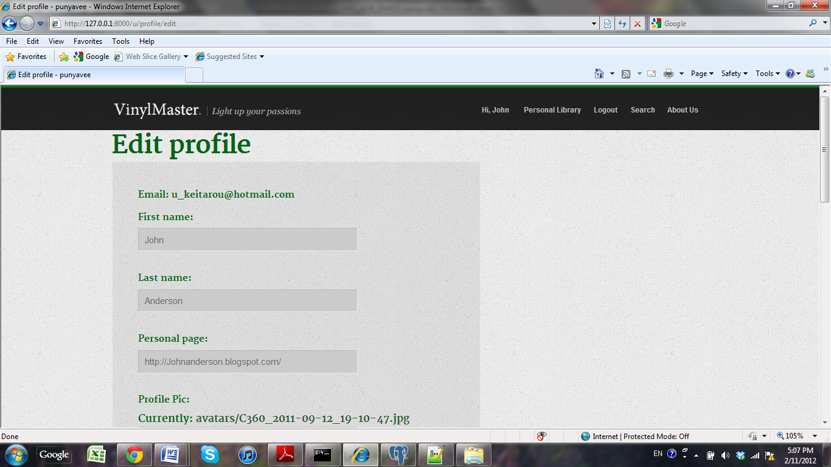

After finishing your edit, click update and you will be leaded to your updated profile account.

**Searching music**

…

**Navigating around the site**

…

**Finding more about us**

You can find our team development information by clicking on “About us” tab.

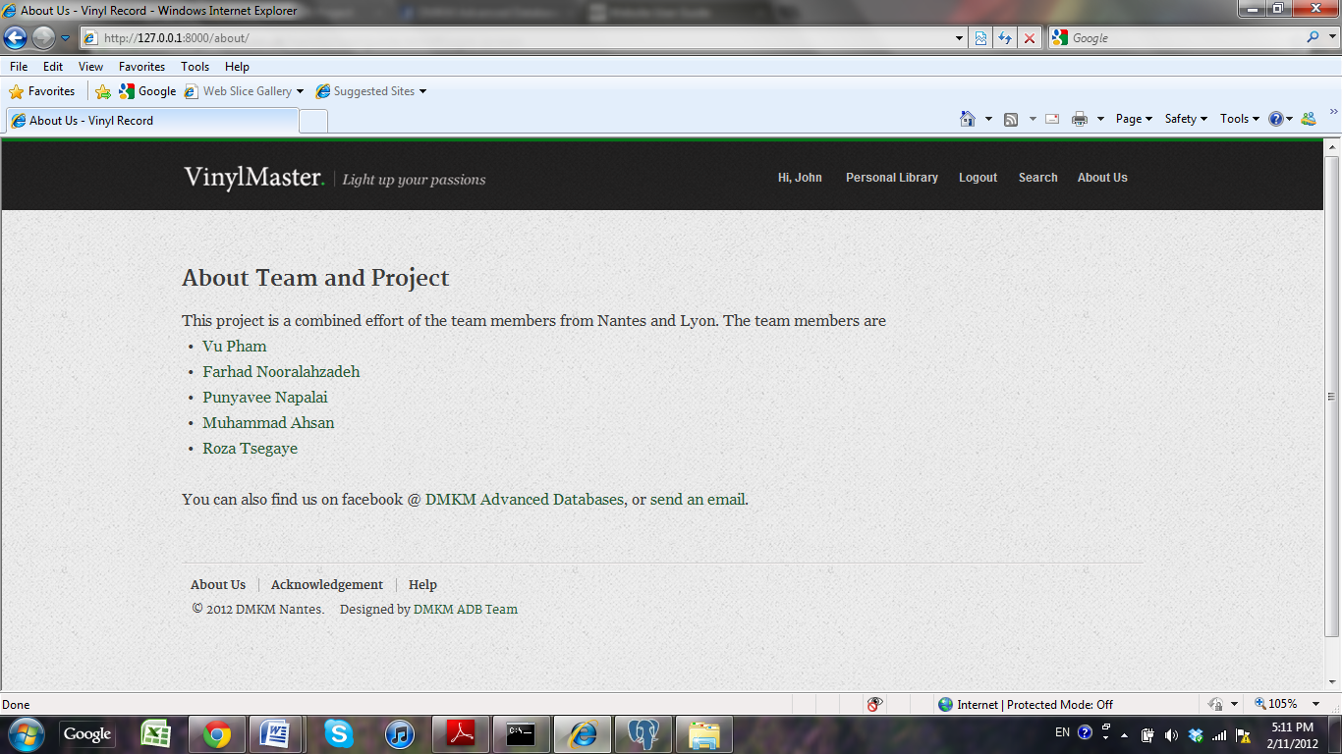

You can find the acknowledgement of this project by clicking on “Acknowledgement” tab.

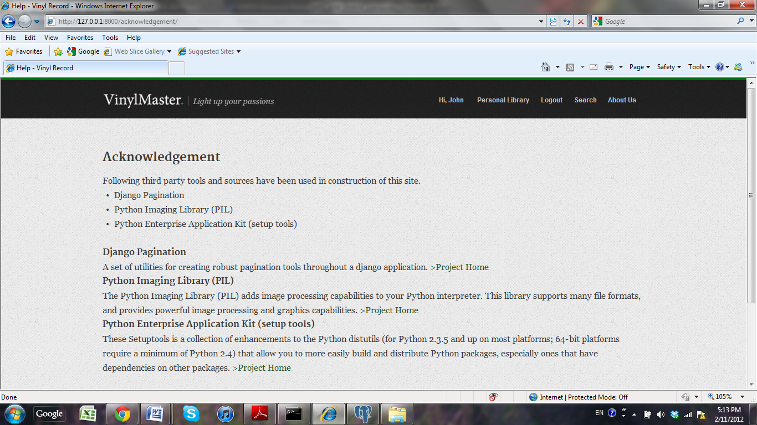

You can find the help and assistance details by clicking on “Help” tab.

